**De-silting Photos**

**D-Block drain ward no.-10E**

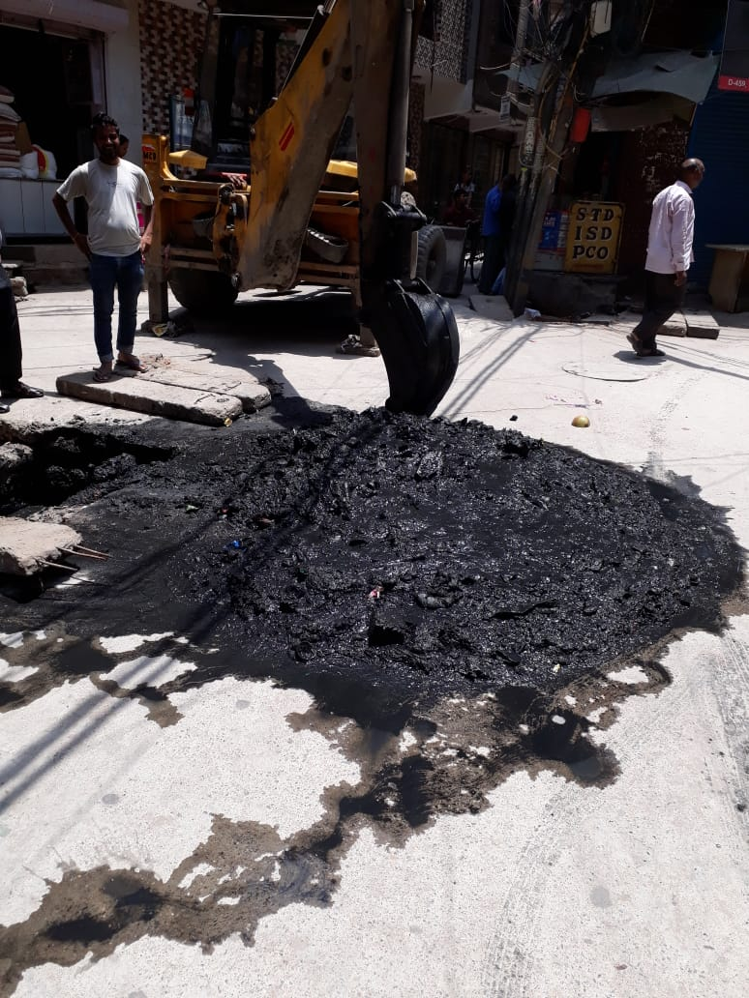

**Near Buddha Marg Mandawali Ward 16 E**

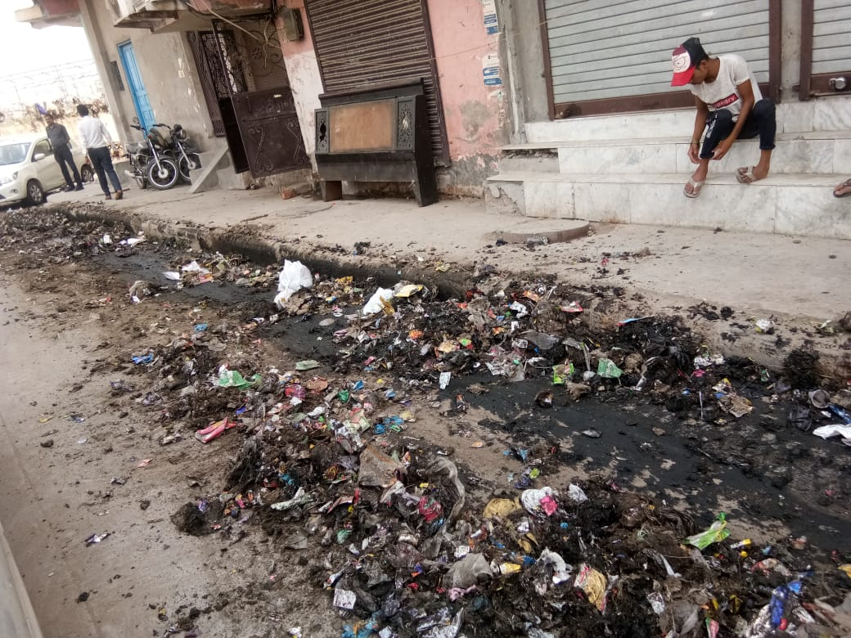

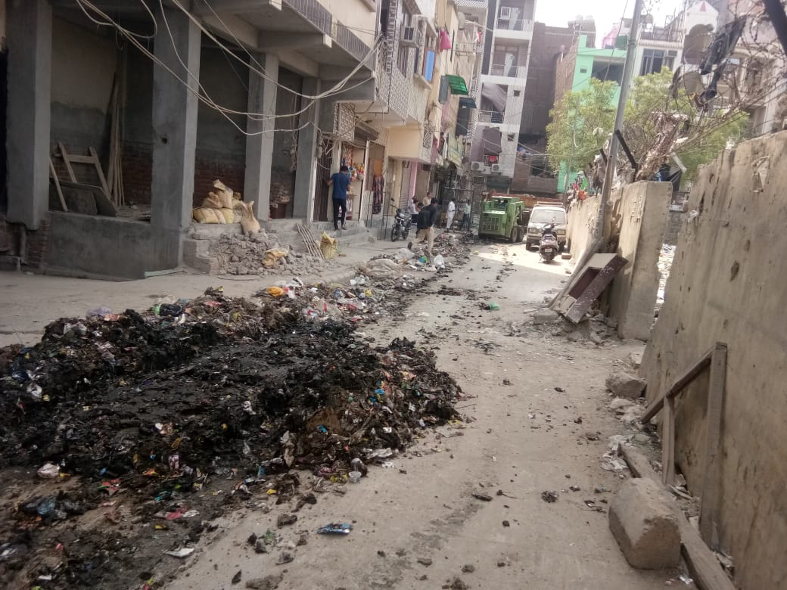

**MB Road ward no 13 E**

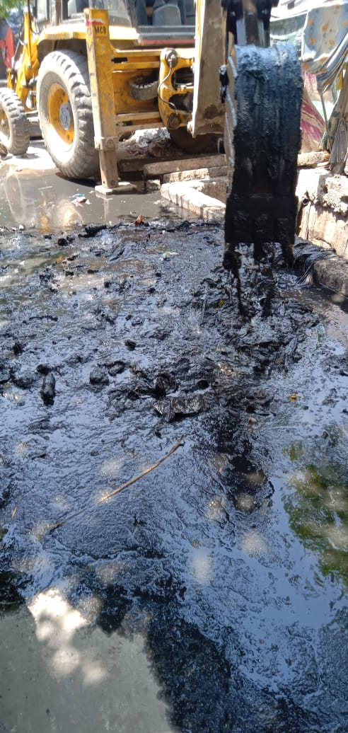

**Shanti Marg Drain**

