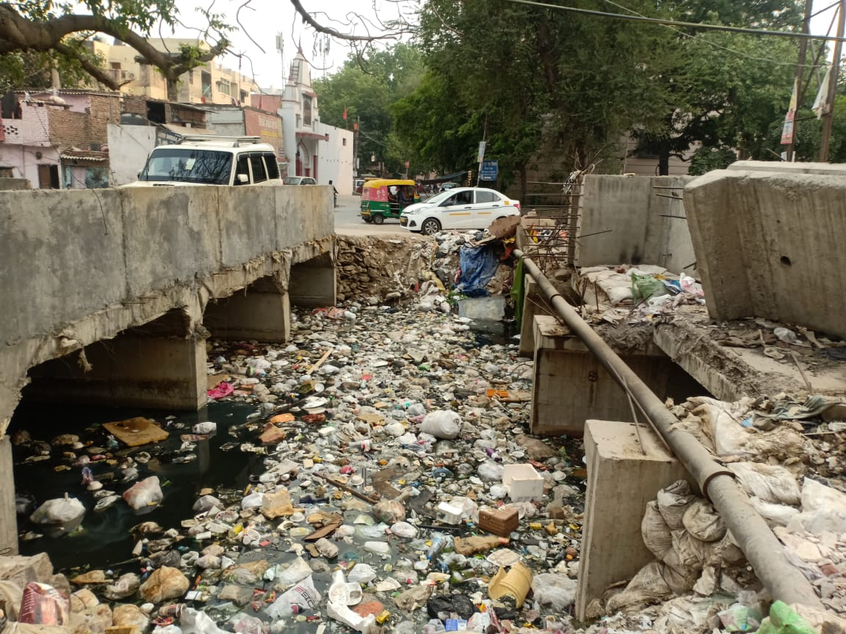
DESILTING OF SUBHASH NAGAR DRAIN (BEFORE)
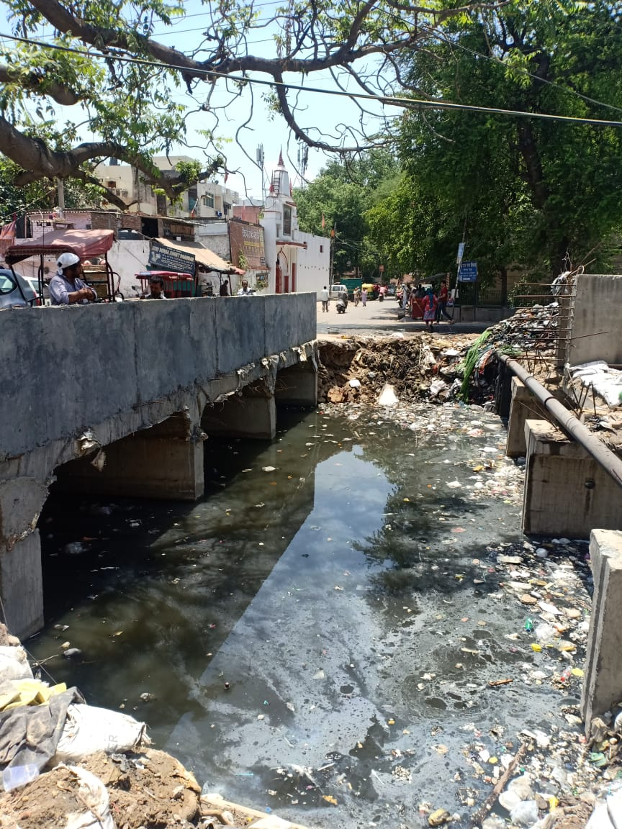 DESILTING OF SUBHASH NAGAR DRAIN (AFTER)

