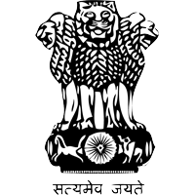
PUBLIC WORKS DEPARTMENT
GOVT. OF DELHI
OFFICE OF THE EXECUTIVE ENGINEER
CIVIL BUILDING MAINTENANCE DIVISION M-422

P.T.S. MALVIYA NAGAR, NEW DELHI-110017 PH: 26564310, FAX: 26858913

Email : eepwddelhim422@gmail.com

File NO :- DB(23)/EE/CBMD/M-422/ Dated:- 04.04.14

To,
Superintending Engineer
CBMC – M – 42
Okhla Fly Over,
Eshwar Nagar,
New Delhi.

Sub: Weekly inspection report (31.03.14 – 04.04.14)

31.03.14

Inspection of Pt. M.M.M. Hospital along with AE Sh. Meena splashes of white washing seen at number of locations at floor/ staircase, cleaning of handrail etc. may be attended immediately.

2. Dholpur stone provided at wall lining work found missing, may be attended immediately. The malba stored in bags may be removed immediately.
(Er. Pratap Singh)
Executive Engineer

1 Assistant Engineer, CBMD- 422, M-4222, PTS Malviya Nagar, New Delhi is directed to attend the above and submitted your weekly inspection report to undersigned .
2 Assistant Engineer M- 4223 Saket Court complex Saket New Delhi-17 is directed to attend the above and submitted your weekly inspection report to undersigned.
.

(Er. Pratap Singh)
Executive Engineer

